**Digital Voice Keyer (DVK)**

# Geoff Anderson G3NPA

## 1.0 GENERAL

The DVK is designed to replay pre-recorded sounds to the user's radio system. Logger32 has three versions of the DVK as follows:

* + One that uses pre-recorded .wav files played via a sound card;
  + One that can be used to trigger pre-recorded messages as used by microHam products that include recorded message playback facilities; and,
  + One that can trigger the built-in message facilities in certain radios.

Only one version may be used at any one time.

All versions of the Digital Voice Keyer (DVK) are accessible by clicking on the DVK icon on the Logger32 Toolbar.



DVK_1

Using the DVK Config menu, select the version of the DVK required. Please note that if port error messages are produced at this stage, simply ignore them.

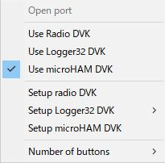

new DVK_2

Having selected the DVK type use the appropriate Setup procedure from the following list.

Number of buttons are user selectable.

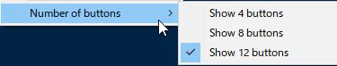

DVK_2A

## 2. SETUP THE LOGGER32 DVK

To use the Logger32 DVK, you must first record your customized voice files. These .wav files can be recorded with an external program, or by using the File | Microsoft Sound Recorder menu option within the DVK. The sound (.wav) files can have any name and be located in a directory of your chose (typically the default Logger32 directory).

### 2.1 Macro setup

Having recorded your .wav files, you need to tell the DVK where to find them.

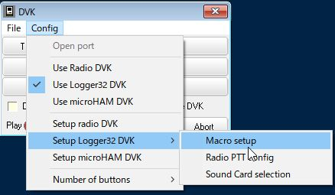

new DVK_3

Select the DVK Config | Macro Setup menu items to open up the Setup DVK dialog box,

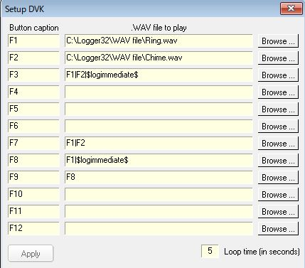

new DVK_4

and enter the appropriate button caption and .wav file details. In the above example just a few buttons are configured.

It is possible to configure combination of WAV file path, RCP macro and Function key number (like F1, F2 etc) Each element is separated by a “|”

The only limitations are that when calling a function key (example F7) cannot be your own function key F7 cannot call F7, and the macro of the function key being called cannot be complex (it must only have a WAV file). Try to break the rules, and the macro is simply ignored.

These sample works like this.  
F1: Play C:\Logger32\WAV file\Ring.wav  
F2: Play C:\Logger32\WAV file\Chime.wav  
F3: Play C:\Logger32\WAV file\Ring.wav then C:\Logger32\WAV file\Chime.wav and log QSO.  
F7: Play C:\Logger32\WAV file\Ring.wav then C:\Logger32\WAV file\Chime.wav  
F8: Play C:\Logger32\WAV file\Ring.wav and log QSO.

F9: Does nothing.

The loop time is the interval between the end of your message and the start of the repeat (if you have selected the <**Loop**> button on the main panel). This time delay is the same for all button selections.

To save your setup, select the <**Apply**> button.

### 2.2 PTT config

The DVK can key the transmitter either by selecting "VOX" on the radio, or by keying the PTT. The DVK menu option Config | Setup Logger32 DVK | Radio PTT will display the DVK Port setup dialog box. Select the PTT method and PTT Keying options as required and then the <**Apply**> button.

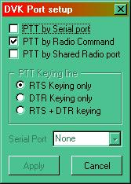

DVK_5

### 2.3 Sound Card selection

The DVK menu optiosn Config | Setup Logger32 DVK | Sound card Selection will display the DVK Sound card selection dialog box and a list of available sound cards. Select the desired sound card and the <**Apply**> button.

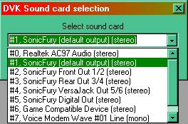

DVK_6

### 2.4 Operation

On closing the setup window you will be returned to the main DVK control panel shown below.

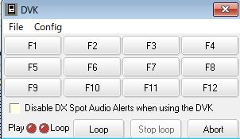

new DVK_7

Clicking on any one of the upper buttons will play your file via the sound card (see **Note 1** below). If you wish to use the loop facility, select on the <**Loop**> button and follow this with the selected announcement button. The <**Abort**> button will immediately terminate any voice file that is playing. The LEDs will indicate the current status.

If you wish to silence the DX spot audio alerts while the DVK is in operation, then simply check the box.

**Note** 1: In Logger32 versions BEFORE ver3.3.0 the DVK used the Windows operating system default sound card.

In version 3.3.0 the DVK used the sound device was defined in the digital sound card option Settings| Sound card Setup.

In versions 3.4.0 the DVK uses the sound card as defined in DVK|Config|Sound card Selection.

### 2.5 Shortcut Keys

The DVK supports the following hotkeys if the focus is on the DVK window:

* + <**F1**> to <**F12**> ~~<~~**~~F8~~**~~>~~  Selects one of the Sound play buttons
  + <**Ctrl+L**> Turns Loop on
  + <**Ctrl+S**> Stops Play
  + <**Ctrl+A**> or <**Esc**> Aborts play.

If the focus is in the Logbook Entry Window ~~Log Input window~~, ~~then only the <~~**~~F1~~**~~> to <~~**~~F4~~**~~> and~~ <**ESC**> keys will function.

**Note**: Intercept of the keys from the Logbook Entry window is by the CW Machine, else the Sound Card Data window, else the DVK. If the CW Machine is loaded it will intercept the <**Fn**> keys. If the Sound Card Data window is loaded, it gets the keys. If neither of these is loaded, then the DVK gets the keys.

**Note:**

a) Messages can be queued. Click button 1, then button 2 then button 3. The DVK plays one, two, then three.

b) Buttons can be clicked by mouse, or by function keys (F1 - F12) from the Logbook Entry Window. or when the focus is on the DVK ... Works best if Global capture of function keys is OFF.

### 2.6 Disable DX Spot Audio Alerts while DVK Window is displayed

The box just above the Play and Loop LEDs provides the capability to disable DX spot audio alerts.This allows the DVK to be used while the DX Spots window can continue to display incoming spots.

An example of using this feature is, using the DVK to call CQ on a loop to open a dead band. If the audio alerts feature has been implemented, (right-click DX Spots window | Setup | Enable audio alerts) any alert (such as "New Band Country" or "Country Not Confirmed") will not be transmitted over the air.

## 3.0 SETUP THE MICROHAM DVK

The Logger32 DVK can be used to trigger any one of the first eight (8) pre-recorded messages as set up in the microHAM router DVK tab. It is assumed that these messages have already been recorded using the microHam facilities as the Logger32 DVK will only trigger these for playback. The Logger32 DVK offers no facility to record these messages.

**Note** that DVK messages are appropriate for microKEYER, microKEYER II and MK2R/MK2R+ units only. They are not supported with DigiKeyer, CW Keyer or USB Interface II.

### 3.1 Config

Select the DVK menu option Config. | Setup microHAM DVK to set up the button definitions, the loop time delay and the control port details, as shown below.

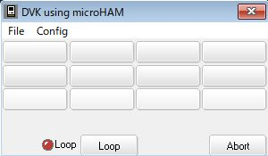

new DVK_8

Simply enter the required captions into the appropriate edit boxes, select the Serial Port, enter the Loop time and then select the <**Apply**> button.

The DVK communicates with the microHAM unit via a virtual control port. This virtual port is created within the microHAM router software and described below. **Note** that there is no need to define any more than just the port number.

### 3.2 Set-up control port for the microHam

You must initially create a virtual port to be used for control purposes in the device router. Use the microHAM menu option Virtual Port| Create. Once done you can then set this port number into the Control Port pane on the PORTS tab.

**Note** that this port is only going to be used for DVK triggering and therefore you are advised to check that the radio button called "microHAM control protocol on Com port" in the SO2R tab (MK2R/MK2R+ only) is NOT activated.

The screenshot below shows where (in this case) Com 9 port selection is entered in the microHam router setup. [See Control bottom left and indicated with cursor arrow]

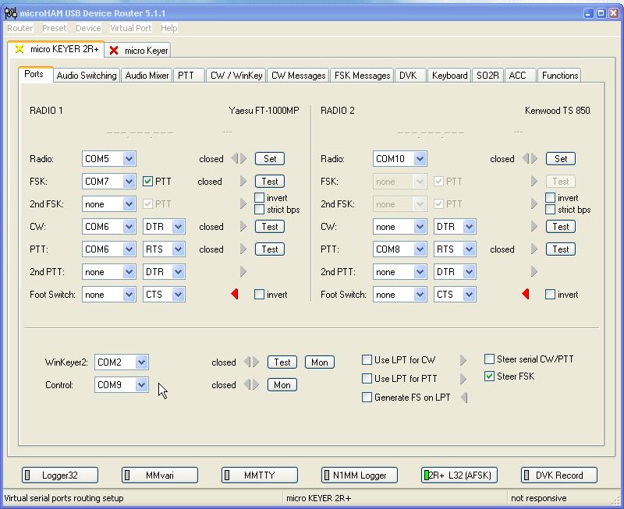

DVK_9

### 3.3 Operation

Selecting each button will trigger the messages stored in the microHAM unit. If you wish to "loop" any announcement, select the <**Loop**> button and then the message button desired. The delay between repeat messages can be set in the setup DVK window [see DVK_8 above] and to stop the loop, select the abort button.

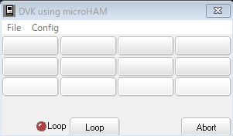

new DVK_10

## 4.0 SETUP THE RADIO DVK

This option allows the user to trigger the inbuilt sound recording memories in certain radios. Currently only the Elecraft K2/K3, and the Yaesu FT2000 and FT9000 are specifically addressed but others can be coded in the future. The memories are triggered by sending codes directly to the radio over the CAT interface and these codes are dependant on the particular radio command set.

### 4.1 Config

There is no need to advise Logger32 of the radio type (for the DVK option) as this is derived from the information contained in the Radio Configuration data, which is set up elsewhere for the CAT interface. However, the button captions require configuration using the DVK menu options Config | Setup Radio DVK. Simply enter the desired captions and select the <**Apply**> button.

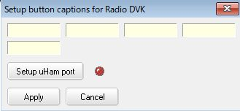

new DVK_11

### 4.2 Operation

Select the desired button to trigger the radio memory.

**Note**: There is no looping facility available for this option (because Logger32 does not know when a particular message has concluded).

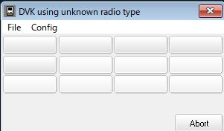

new DVK_12

**Note**: For SO2R users, you should make sure that both radios contain the same message for each message button as there is only one button set in Logger32. The window title will change when you swap radios (if you use different radio types) once a button is depressed.